**Group 16**



Database Project

(CMPG321)

**Group Members:**

36787426 – R Mmutlwane– (Group Leader)

31846769 – C.M Ngokana

31889689 – P.J Thwala

30056136 – R van der Walt

37324519 – E Shuro

32021119 – JK Ntlhane

Submission date: 18/10/2023

Table of Contents

**1.** **Project Deliverable 1 –** Requirements Analysis and Conceptual Database Design 3

1.1 Background & Requirements Analysis 3

1.2 Business Rules 5

1.3 Group Conceptual Design 6

1.4 Members’ Conceptual Designs 7

1.4.1 R Mmutlwane (36787426) 7

1.4.2 C.M Ngokana (31846769) 8

1.4.3 P.J Thwala (31889689) 9

1.4.4 R van der Walt (30056136) 10

1.4.5 E Shuro (37324519) 11

1.4.6 JK Ntlhane (32021119) 12

2. **Project Deliverable 2 *–*** Logical and Physical Design 13

2.1 Group logical design 13

2.2 Normalization 14

2.2.1 Dependency diagrams 14

2.3 Modeller using Oracle 18

2.3.1 Modeller Part 1 18

2.3.2 Modeller Part 2 18

2.3.3 Modeller Part 3 19

2.3.4 Whole Modeller 19

2.4 Schema generated using SQL code plan 20

# Project Deliverable 1 – Requirements Analysis and Conceptual Database Design

## Background & Requirements Analysis

In response to the challenges of traffic congestion, road safety, and sustainability within North-West University (NWU) campuses, there's a pressing need for a data-driven approach to optimize traffic management. To address these challenges effectively, our project aims to develop a Smart Traffic Management Database System, integrating smart city technologies to enhance urban mobility, reduce congestion, and foster a more sustainable campus environment.

**Objective:** The primary objective is to design and implement a fully functional database system that empowers traffic management authorities with data-driven insights. By doing so, we intend to optimize transportation flow, enhance pedestrian and bicycle commuting options, and create a safer and more sustainable living environment within NWU campuses.

We acknowledge the challenges posed by traffic congestion, safety concerns, and the need for eco-friendly commuting options within NWU campuses. We propose a comprehensive Smart Traffic Management Database System to address these issues.

1. **Smart City Technologies Integration:**
   * **Traffic Signal Optimization:** Utilizing traffic lights, cameras, and sensors, we plan to implement an adaptive traffic signal system. Real-time data from these sources will enable dynamic adjustments to signal timings, aiming to optimize traffic flow and minimize congestion.
   * **Vehicle Attributes and Road Conditions:** Our system will consider vehicle speed, size, and road conditions such as potholes. This comprehensive data analysis will help us proactively address congestion sources.
2. **Parking Space Management:**
   * **Occupancy Tracking:** We will monitor parking space occupancy and predicted availability based on historical data across NWU campuses.
   * **Variable Message Signs:** Leveraging the occupancy data, we'll implement variable message signs to guide users to available parking spots, reducing traffic caused by parking searches.
3. **Entry/Exit Point Monitoring:**
   * **Congestion Analysis:** We will monitor traffic patterns at entry/exit points to identify congestion points and understand user behaviour during entry/exit.
   * **Alternate Gate Recommendations:** Real-time information will allow us to recommend less congested entry/exit gates, improving overall entry/exit efficiency.
4. **Environmental Impact and Sustainability:**
   * By reducing congestion and optimizing traffic flow, our system indirectly contributes to reduced fuel consumption and emissions, aligning with NWU's sustainability goals.
5. **Data Integration and Analysis:**
   * Data from various sources, including cameras, sensors, and user feedback, will be integrated, and analysed in real-time to make informed traffic management decisions.
6. **Usability and User Engagement:**
   * User-friendly interfaces, mobile apps, and web platforms will enable users to access real-time traffic information, receive alerts, and provide feedback, fostering community involvement.
7. **Predictive Analytics and Future Expansion:**
   * We aim to implement predictive analytics based on historical and real-time data to anticipate traffic patterns during events and peak hours.
   * The system's architecture will be designed with scalability in mind, enabling future expansion to include additional smart city features.
8. **Collaboration with Stakeholders:**
   * Regular communication with NWU stakeholders, including traffic management authorities, campus users, and IT teams, will ensure the system meets their needs.
9. **Security and Privacy Measures:**

* We will prioritize data security and privacy, implementing robust measures to safeguard sensitive information and comply with data protection regulations.

## Business Rules

Business rules:

* A traffic light monitors one and only one road/street. A road/street is monitored by zero or more traffic lights.
* A road can have zero or many vehicles (traffic). A vehicle (traffic) is found on one and only one road.
* A road has zero or more parking areas. Zero to many parking areas belong to one road.
* A gate has zero or more traffic. A traffic is associated with one or more gate.
* A gate has three types: boom gate, cyclist gate, or turnstile.

Assumptions:

* We assume that the North-West University allows for traffic monitoring with already set up technologies.
* We assume the parking areas are accessed from a main entrance connecting to a single road.
* We also assume that cameras and/or other technologies are able to count the number of parking spaces that are available and derive number of parking spots left.

Our business rules are derived from Google Earth, Google Maps, and The internet, more specifically the TomTom website which also has a traffic management component ([TomTom GPS Sat Nav - Traffic Alerts, Maps & Apps](https://www.tomtom.com/en_za/navigation/)).

## Group Conceptual Design

## Members’ Conceptual Designs

### R Mmutlwane (36787426)

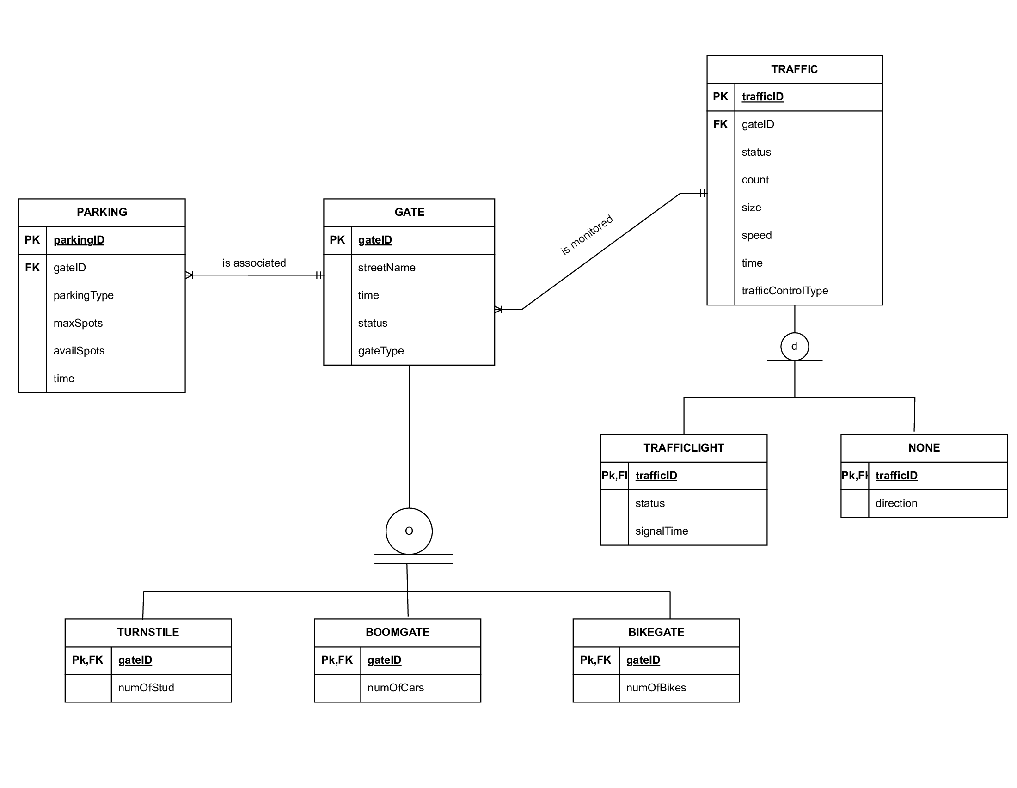

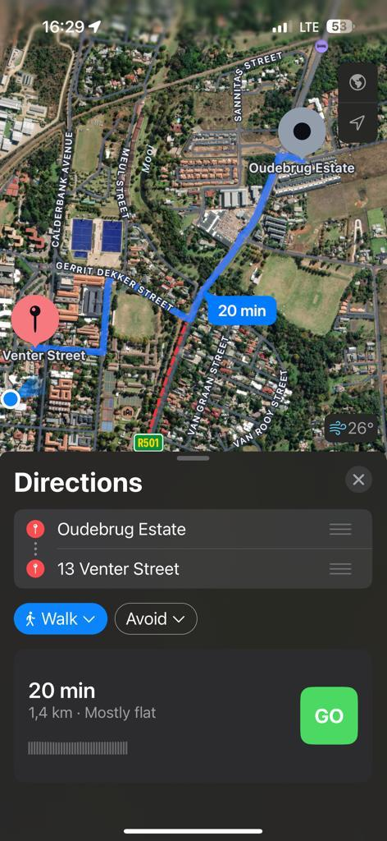

### C.M Ngokana (31846769)

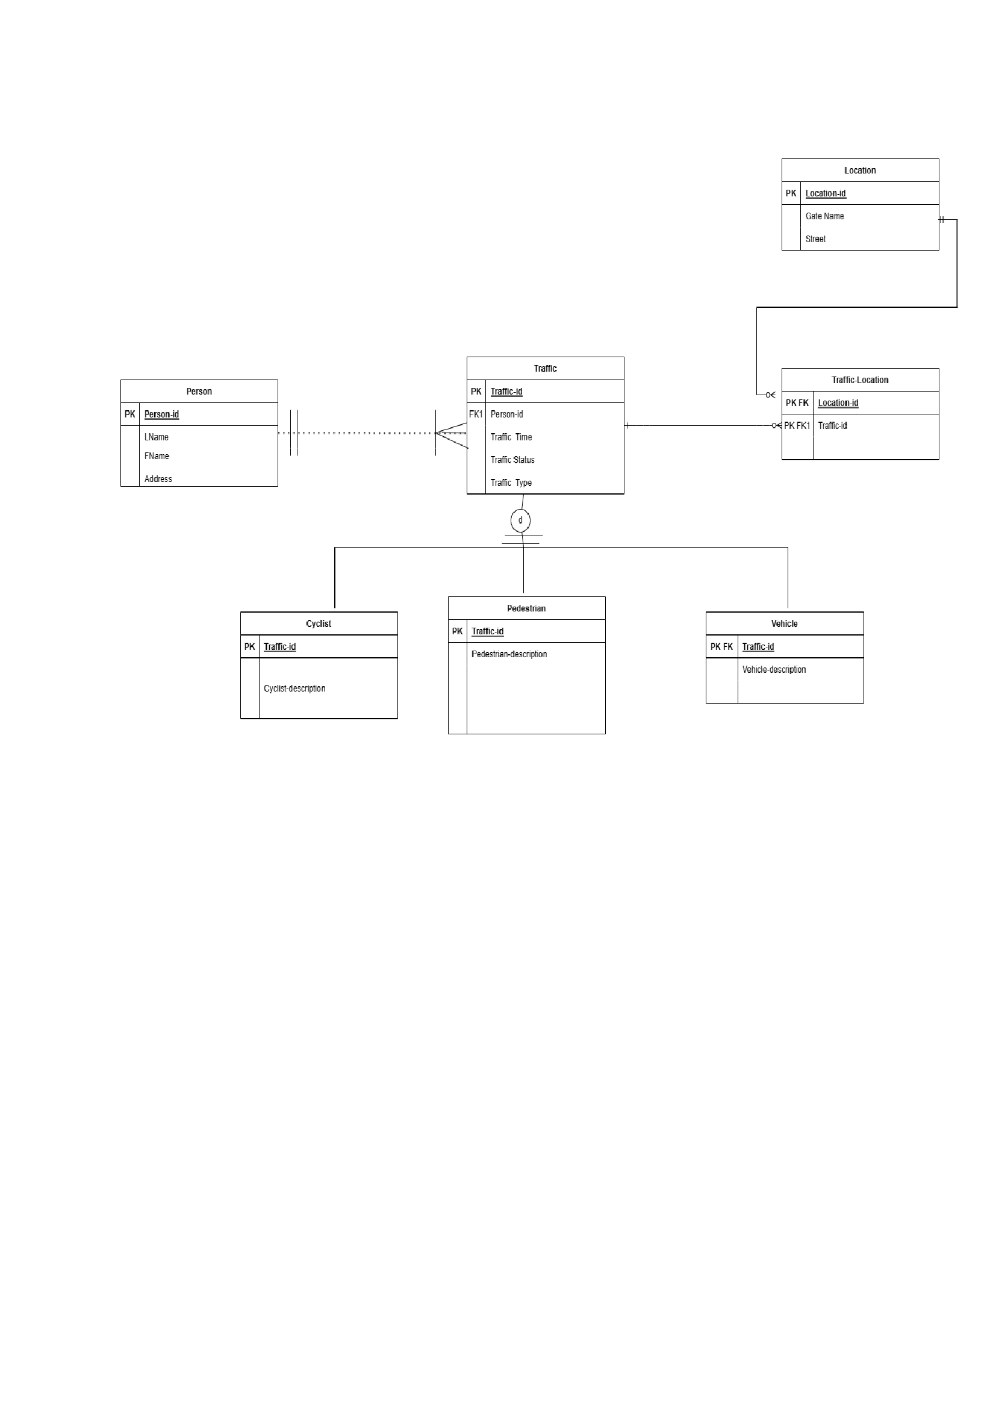

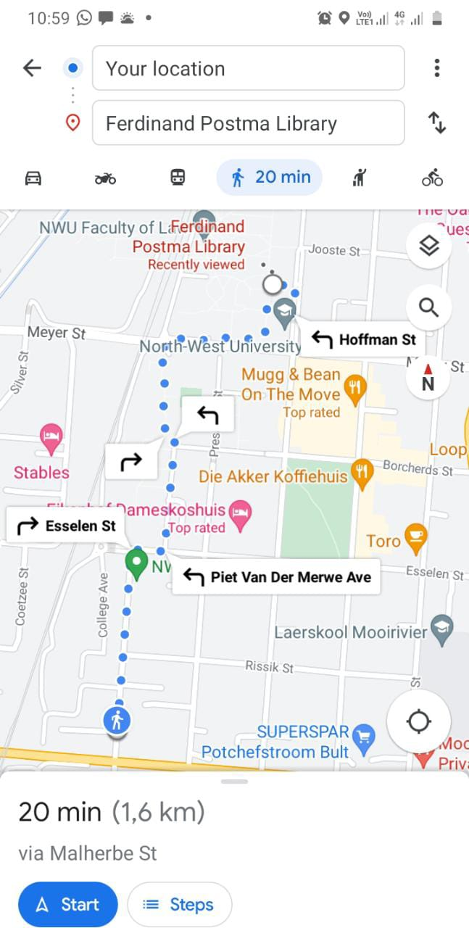

### P.J Thwala (31889689)

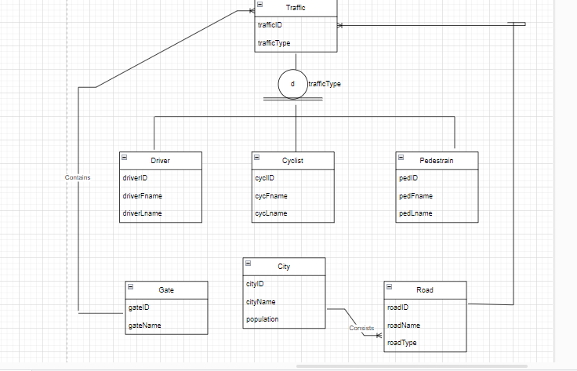

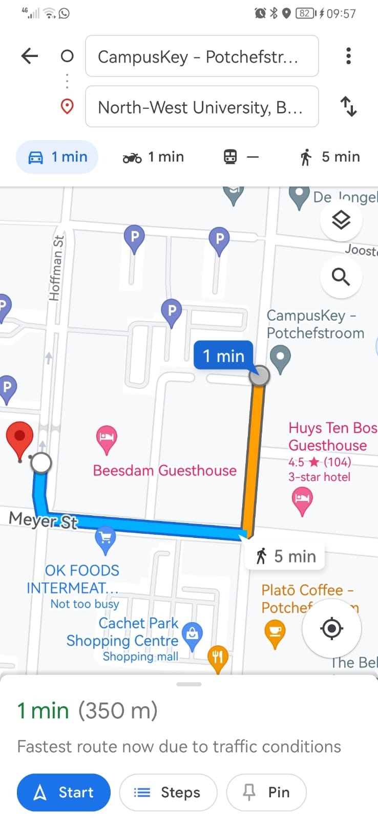

### R van der Walt (30056136)

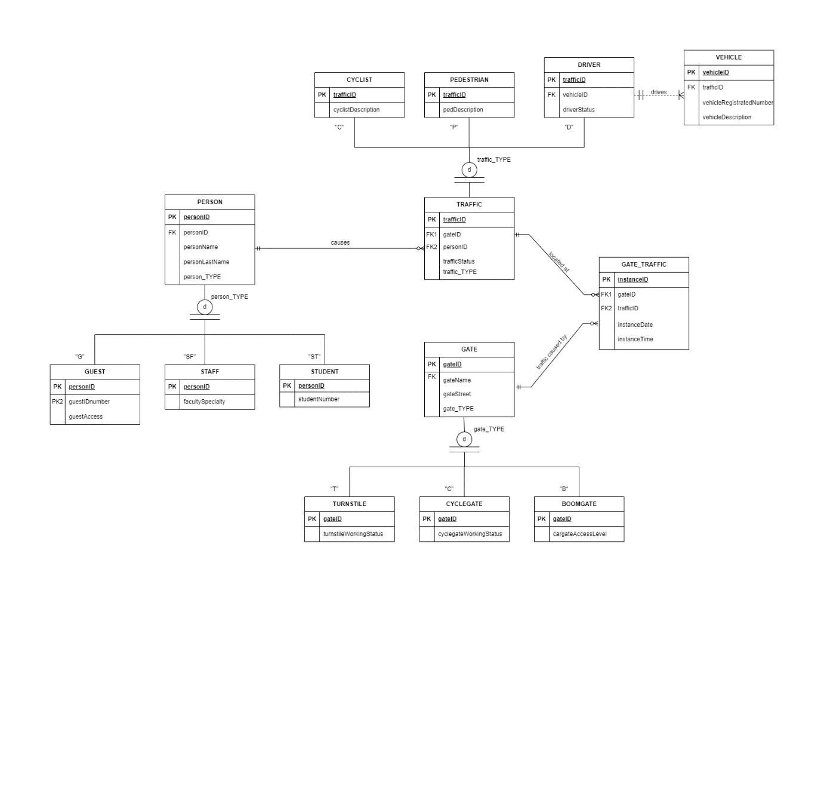

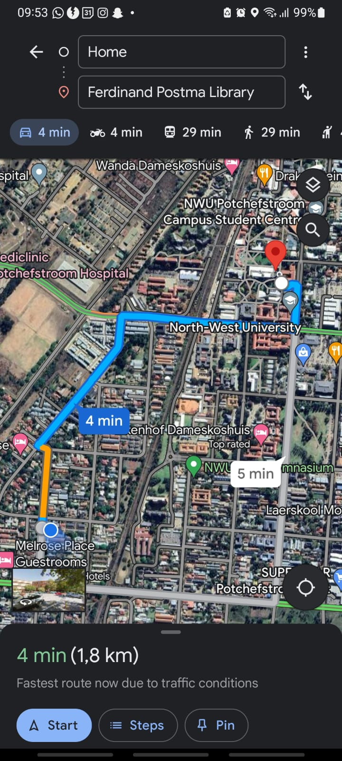

### E Shuro (37324519)

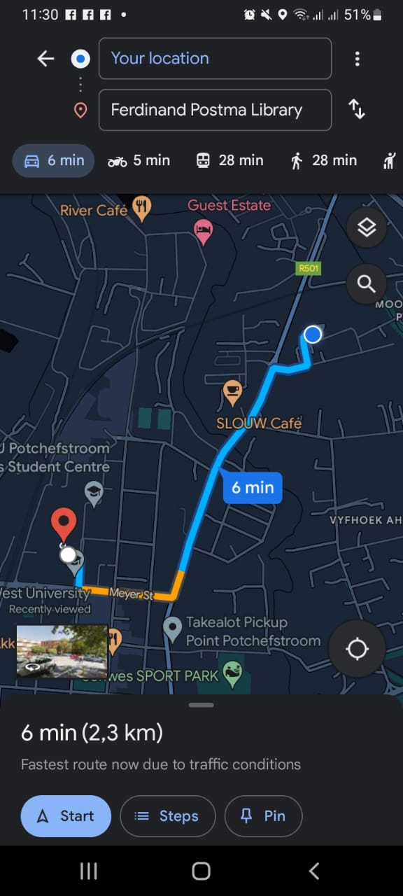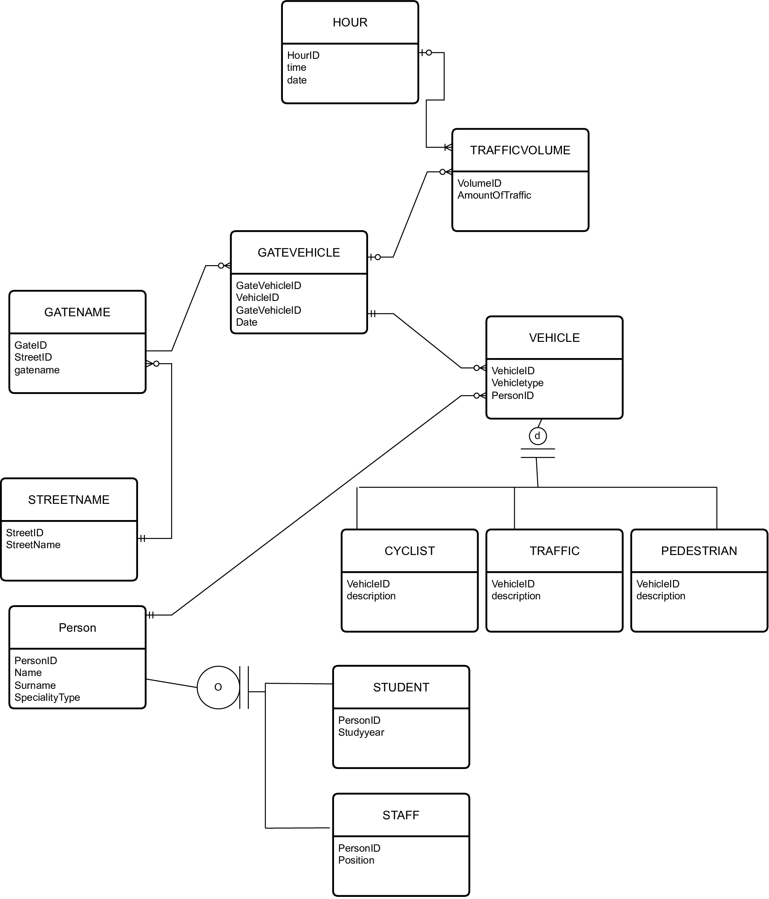

### JK Ntlhane (32021119)

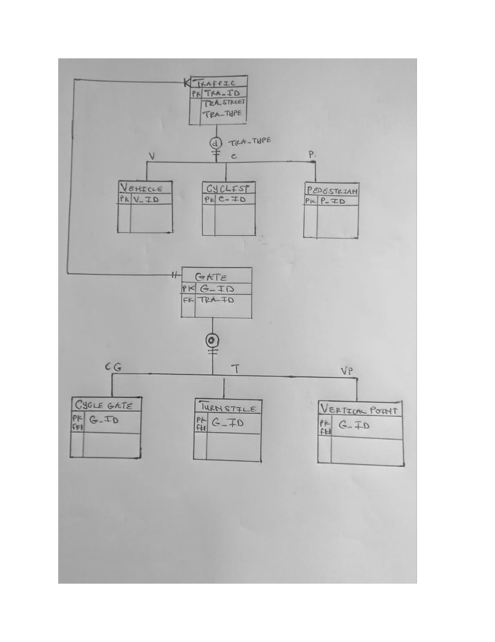

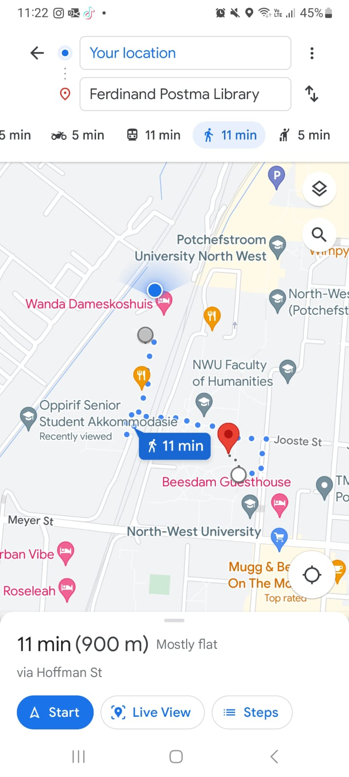

# Project Deliverable 2 – Logical and Physical Design

## Group logical design

Business rules:

* A traffic light monitors one and only one road/street. A road/street is monitored by zero or more traffic light.
* A road can have zero or many vehicles (traffic). A vehicle (traffic) is found on one and only one road.
* A road has zero or more parking areas. Zero to many parking areas belong to one road.
* A gate has zero or more traffic. A traffic is associated with one or more gate.
* A gate has three types: boom gate, cyclist gate, or turnstile.
* A road has one or more road-view image. One or more road-view images belong to one road.
* One route option has zero or more traffic. Zero or more traffic occurs on one route option

## Normalization

### Dependency diagrams

Initial tables before normalization.

Attribute names from left to right:

1. RoadID 8. Roadname 15.TrafficType 22. GateStreet 29. DestLocation
2. TrafficID 9. RoadCondition 16. WorkingStatus 23. GateType 30. StartLocation
3. ParkingID 10. Speed 17. SignalTime 24. TurnstileWorkingStatus 31. ETA
4. GateID 11. RoadDistance 18. ParkingName 25. CycleGateStatus
5. ImageID 12. VehicleType 19. FacultyName 26. CargateAccessLevel
6. RouteOptionID 13. TrafficTime slot 20. ParkingAvailable 27. Datecaptured
7. TrafficLightID 14. TrafficStatus 21. GateName 28. RoadViewImage

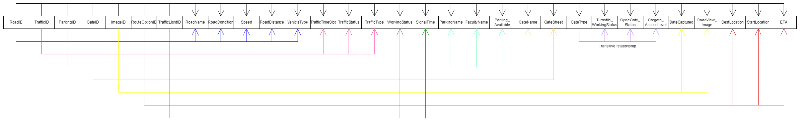

#### Tables in 3NF

Table name: Road

Road (roadID, roadName, roadCondition, speed, roadDistance, vehicleType)

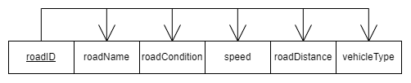

Table name: Traffic

Traffic (trafficID, trafficTimeslot,TrafficStatus, trafficType)

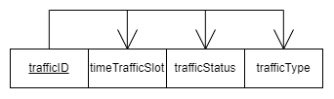

Table name: ParkingArea

Traffic (parkingID, roadID, parkingName, facultyName, parkingAvailable)

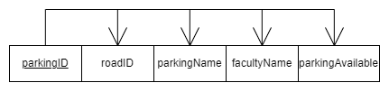

Table name: Gate

Gate (gateID, gateName, gateStreet, gateType)

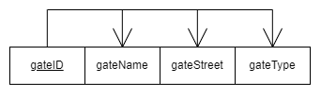

Table name: BoomGate

BoomGate (gateID, cargateAccessLevel)

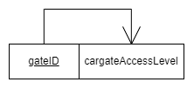

Table name: Turnstile

Turnstile (gateID, turnstileWorkingStatus)

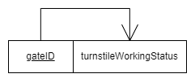

Table name: CycleGate

CycleGate (gateID, cycleGateWorkingStatus)

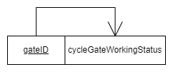

Table name: Image

Image (imageID, roadID, DateCaptured, image)

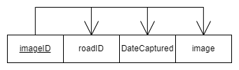

Table name: RouteOption

RouteOption (RouteOptionID, trafficID, destLocation, ETA, startLocation)

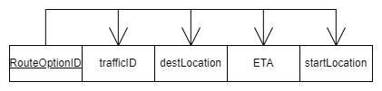

Table name: TrafficLight

TrafficLight (trafficLightID, trafficTimeSlot, trafficStatus, trafficType)

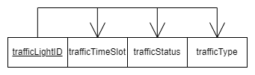

## Modeller using Oracle

### Modeller Part 2

### A diagram of a computer server Description automatically generated with medium confidenceModeller Part 3

### Whole Modeller

## Schema generated using SQL code plan

--------------------------------------------------------

-- DDL for Sequence DEPARTMENTS_SEQ

--------------------------------------------------------

CREATE SEQUENCE "HR"."DEPARTMENTS_SEQ" MINVALUE 1 MAXVALUE 9990 INCREMENT BY 10 START WITH 280 NOCACHE NOORDER NOCYCLE ;

--------------------------------------------------------

-- DDL for Sequence EMPLOYEES_SEQ

--------------------------------------------------------

CREATE SEQUENCE "HR"."EMPLOYEES_SEQ" MINVALUE 1 MAXVALUE 9999999999999999999999999999 INCREMENT BY 1 START WITH 207 NOCACHE NOORDER NOCYCLE ;

--------------------------------------------------------

-- DDL for Sequence LOCATIONS_SEQ

--------------------------------------------------------

CREATE SEQUENCE "HR"."LOCATIONS_SEQ" MINVALUE 1 MAXVALUE 9900 INCREMENT BY 100 START WITH 3300 NOCACHE NOORDER NOCYCLE ;

--------------------------------------------------------

-- DDL for Table BOOMGATE

--------------------------------------------------------

CREATE TABLE "HR"."BOOMGATE"

( "GATE_ID" NUMBER(6,0),

"CARGATE_ACCESS_LEVEL" VARCHAR2(20 BYTE)

) SEGMENT CREATION IMMEDIATE

PCTFREE 10 PCTUSED 40 INITRANS 1 MAXTRANS 255 NOCOMPRESS LOGGING

STORAGE(INITIAL 65536 NEXT 1048576 MINEXTENTS 1 MAXEXTENTS 2147483645

PCTINCREASE 0 FREELISTS 1 FREELIST GROUPS 1 BUFFER_POOL DEFAULT FLASH_CACHE DEFAULT CELL_FLASH_CACHE DEFAULT)

TABLESPACE "USERS" ;

--------------------------------------------------------

-- DDL for Table CYCLEGATE

--------------------------------------------------------

CREATE TABLE "HR"."CYCLEGATE"

( "GATE_ID" NUMBER(6,0),

"CYCLEGATE_WORKING_STATUS" VARCHAR2(20 BYTE)

) SEGMENT CREATION IMMEDIATE

PCTFREE 10 PCTUSED 40 INITRANS 1 MAXTRANS 255 NOCOMPRESS LOGGING

STORAGE(INITIAL 65536 NEXT 1048576 MINEXTENTS 1 MAXEXTENTS 2147483645

PCTINCREASE 0 FREELISTS 1 FREELIST GROUPS 1 BUFFER_POOL DEFAULT FLASH_CACHE DEFAULT CELL_FLASH_CACHE DEFAULT)

TABLESPACE "USERS" ;

--------------------------------------------------------

-- DDL for Table GATE

--------------------------------------------------------

CREATE TABLE "HR"."GATE"

( "GATE_ID" NUMBER(6,0),

"GATE_NAME" VARCHAR2(20 BYTE),

"GATE_STREET" VARCHAR2(20 BYTE),

"GATE_TYPE" VARCHAR2(20 BYTE)

) SEGMENT CREATION IMMEDIATE

PCTFREE 10 PCTUSED 40 INITRANS 1 MAXTRANS 255 NOCOMPRESS LOGGING

STORAGE(INITIAL 65536 NEXT 1048576 MINEXTENTS 1 MAXEXTENTS 2147483645

PCTINCREASE 0 FREELISTS 1 FREELIST GROUPS 1 BUFFER_POOL DEFAULT FLASH_CACHE DEFAULT CELL_FLASH_CACHE DEFAULT)

TABLESPACE "USERS" ;

--------------------------------------------------------

-- DDL for Table GATE_TRAFFIC

--------------------------------------------------------

CREATE TABLE "HR"."GATE_TRAFFIC"

( "TRAFFIC_ID" NUMBER(6,0),

"GATE_ID" NUMBER(6,0)

) SEGMENT CREATION IMMEDIATE

PCTFREE 10 PCTUSED 40 INITRANS 1 MAXTRANS 255 NOCOMPRESS LOGGING

STORAGE(INITIAL 65536 NEXT 1048576 MINEXTENTS 1 MAXEXTENTS 2147483645

PCTINCREASE 0 FREELISTS 1 FREELIST GROUPS 1 BUFFER_POOL DEFAULT FLASH_CACHE DEFAULT CELL_FLASH_CACHE DEFAULT)

TABLESPACE "USERS" ;

--------------------------------------------------------

-- DDL for Table PARKING_AREA

--------------------------------------------------------

CREATE TABLE "HR"."PARKING_AREA"

( "PARKING_ID" NUMBER(6,0),

"ROAD_ID" NUMBER(6,0),

"PARKING_NAME" VARCHAR2(20 BYTE),

"FACULTY_NAME" VARCHAR2(20 BYTE),

"PARKING_AVAILABLE" VARCHAR2(20 BYTE)

) SEGMENT CREATION IMMEDIATE

PCTFREE 10 PCTUSED 40 INITRANS 1 MAXTRANS 255 NOCOMPRESS LOGGING

STORAGE(INITIAL 65536 NEXT 1048576 MINEXTENTS 1 MAXEXTENTS 2147483645

PCTINCREASE 0 FREELISTS 1 FREELIST GROUPS 1 BUFFER_POOL DEFAULT FLASH_CACHE DEFAULT CELL_FLASH_CACHE DEFAULT)

TABLESPACE "USERS" ;

--------------------------------------------------------

-- DDL for Table ROAD

--------------------------------------------------------

CREATE TABLE "HR"."ROAD"

( "ROAD_ID" NUMBER(6,0),

"ROAD_NAME" VARCHAR2(20 BYTE),

"ROAD_CONDITION" VARCHAR2(20 BYTE),

"SPEED" NUMBER(20,0),

"ROAD_DISTANCE" NUMBER(20,0),

"VEHICLE_TYPE" VARCHAR2(20 BYTE)

) SEGMENT CREATION IMMEDIATE

PCTFREE 10 PCTUSED 40 INITRANS 1 MAXTRANS 255 NOCOMPRESS LOGGING

STORAGE(INITIAL 65536 NEXT 1048576 MINEXTENTS 1 MAXEXTENTS 2147483645

PCTINCREASE 0 FREELISTS 1 FREELIST GROUPS 1 BUFFER_POOL DEFAULT FLASH_CACHE DEFAULT CELL_FLASH_CACHE DEFAULT)

TABLESPACE "USERS" ;

--------------------------------------------------------

-- DDL for Table ROAD_TRAFFIC

--------------------------------------------------------

CREATE TABLE "HR"."ROAD_TRAFFIC"

( "TRAFFIC_ID" NUMBER(6,0),

"ROAD_ID" NUMBER(6,0)

) SEGMENT CREATION IMMEDIATE

PCTFREE 10 PCTUSED 40 INITRANS 1 MAXTRANS 255 NOCOMPRESS LOGGING

STORAGE(INITIAL 65536 NEXT 1048576 MINEXTENTS 1 MAXEXTENTS 2147483645

PCTINCREASE 0 FREELISTS 1 FREELIST GROUPS 1 BUFFER_POOL DEFAULT FLASH_CACHE DEFAULT CELL_FLASH_CACHE DEFAULT)

TABLESPACE "USERS" ;

--------------------------------------------------------

-- DDL for Table ROAD_VIEW_IMAGE

--------------------------------------------------------

CREATE TABLE "HR"."ROAD_VIEW_IMAGE"

( "IMAGE_ID" NUMBER(6,0),

"ROAD_ID" NUMBER(6,0),

"DATE_CAPTURED" DATE,

"IMAGE" BLOB

) SEGMENT CREATION IMMEDIATE

PCTFREE 10 PCTUSED 40 INITRANS 1 MAXTRANS 255 NOCOMPRESS LOGGING

STORAGE(INITIAL 65536 NEXT 1048576 MINEXTENTS 1 MAXEXTENTS 2147483645

PCTINCREASE 0 FREELISTS 1 FREELIST GROUPS 1 BUFFER_POOL DEFAULT FLASH_CACHE DEFAULT CELL_FLASH_CACHE DEFAULT)

TABLESPACE "USERS"

LOB ("IMAGE") STORE AS BASICFILE (

TABLESPACE "USERS" ENABLE STORAGE IN ROW CHUNK 8192 RETENTION

NOCACHE LOGGING

STORAGE(INITIAL 65536 NEXT 1048576 MINEXTENTS 1 MAXEXTENTS 2147483645

PCTINCREASE 0 FREELISTS 1 FREELIST GROUPS 1 BUFFER_POOL DEFAULT FLASH_CACHE DEFAULT CELL_FLASH_CACHE DEFAULT)) ;

--------------------------------------------------------

-- DDL for Table TURNSTILE

--------------------------------------------------------

CREATE TABLE "HR"."TURNSTILE"

( "GATE_ID" NUMBER(6,0),

"TURNSTILE_WORKING_STATUS" VARCHAR2(20 BYTE)

) SEGMENT CREATION IMMEDIATE

PCTFREE 10 PCTUSED 40 INITRANS 1 MAXTRANS 255 NOCOMPRESS LOGGING

STORAGE(INITIAL 65536 NEXT 1048576 MINEXTENTS 1 MAXEXTENTS 2147483645

PCTINCREASE 0 FREELISTS 1 FREELIST GROUPS 1 BUFFER_POOL DEFAULT FLASH_CACHE DEFAULT CELL_FLASH_CACHE DEFAULT)

TABLESPACE "USERS" ;

--------------------------------------------------------

-- DDL for Table ROUTE_OPTION

--------------------------------------------------------

CREATE TABLE "HR"."ROUTE_OPTION"

( "ROUTE_OPTION_ID" NUMBER(6,0),

"TRAFFIC_ID" NUMBER(6,0),

"DEST_LOCTAION" VARCHAR2(20 BYTE),

"SOURCE_LOCATION" VARCHAR2(20 BYTE),

"ESTIMATED_TIME" TIMESTAMP (6)

) SEGMENT CREATION IMMEDIATE

PCTFREE 10 PCTUSED 40 INITRANS 1 MAXTRANS 255 NOCOMPRESS LOGGING

STORAGE(INITIAL 65536 NEXT 1048576 MINEXTENTS 1 MAXEXTENTS 2147483645

PCTINCREASE 0 FREELISTS 1 FREELIST GROUPS 1 BUFFER_POOL DEFAULT FLASH_CACHE DEFAULT CELL_FLASH_CACHE DEFAULT)

TABLESPACE "USERS" ;

--------------------------------------------------------

-- DDL for Table TRAFFIC

--------------------------------------------------------

CREATE TABLE "HR"."TRAFFIC"

( "TRAFFIC_ID" NUMBER(6,0),

"TRAFFIC_TIME_SLOT" VARCHAR2(20 BYTE),

"TRAFFIC_STATUS" VARCHAR2(20 BYTE),

"TRAFFIC_TIME" TIMESTAMP (6)

) SEGMENT CREATION IMMEDIATE

PCTFREE 10 PCTUSED 40 INITRANS 1 MAXTRANS 255 NOCOMPRESS LOGGING

STORAGE(INITIAL 65536 NEXT 1048576 MINEXTENTS 1 MAXEXTENTS 2147483645

PCTINCREASE 0 FREELISTS 1 FREELIST GROUPS 1 BUFFER_POOL DEFAULT FLASH_CACHE DEFAULT CELL_FLASH_CACHE DEFAULT)

TABLESPACE "USERS" ;

--------------------------------------------------------

-- DDL for Table TRAFFIC_LIGHT

--------------------------------------------------------

CREATE TABLE "HR"."TRAFFIC_LIGHT"

( "TRAFFIC_LIGHT_ID" NUMBER(6,0),

"ROAD_ID" NUMBER(6,0),

"WORKING_STATUS" VARCHAR2(20 BYTE),

"SIGNAL_TIME" VARCHAR2(20 BYTE)

) SEGMENT CREATION IMMEDIATE

PCTFREE 10 PCTUSED 40 INITRANS 1 MAXTRANS 255 NOCOMPRESS LOGGING

STORAGE(INITIAL 65536 NEXT 1048576 MINEXTENTS 1 MAXEXTENTS 2147483645

PCTINCREASE 0 FREELISTS 1 FREELIST GROUPS 1 BUFFER_POOL DEFAULT FLASH_CACHE DEFAULT CELL_FLASH_CACHE DEFAULT)

TABLESPACE "USERS" ;

--------------------------------------------------------

-- DDL for View EMP_DETAILS_VIEW

--------------------------------------------------------

CREATE OR REPLACE FORCE VIEW "HR"."EMP_DETAILS_VIEW" ("EMPLOYEE_ID", "JOB_ID", "MANAGER_ID", "DEPARTMENT_ID", "LOCATION_ID", "COUNTRY_ID", "FIRST_NAME", "LAST_NAME", "SALARY", "COMMISSION_PCT", "DEPARTMENT_NAME", "JOB_TITLE", "CITY", "STATE_PROVINCE", "COUNTRY_NAME", "REGION_NAME") AS

SELECT

e.employee_id,

e.job_id,

e.manager_id,

e.department_id,

d.location_id,

l.country_id,

e.first_name,

e.last_name,

e.salary,

e.commission_pct,

d.department_name,

j.job_title,

l.city,

l.state_province,

c.country_name,

r.region_name

FROM

employees e,

departments d,

jobs j,

locations l,

countries c,

regions r

WHERE e.department_id = d.department_id

AND d.location_id = l.location_id

AND l.country_id = c.country_id

AND c.region_id = r.region_id

AND j.job_id = e.job_id

WITH READ ONLY

;

REM INSERTING into HR.BOOMGATE

SET DEFINE OFF;

REM INSERTING into HR.CYCLEGATE

SET DEFINE OFF;

REM INSERTING into HR.GATE

SET DEFINE OFF;

REM INSERTING into HR.GATE_TRAFFIC

SET DEFINE OFF;

REM INSERTING into HR.PARKING_AREA

SET DEFINE OFF;

REM INSERTING into HR.ROAD

SET DEFINE OFF;

REM INSERTING into HR.ROAD_TRAFFIC

SET DEFINE OFF;

REM INSERTING into HR.ROAD_VIEW_IMAGE

SET DEFINE OFF;

REM INSERTING into HR.ROUTE_OPTION

SET DEFINE OFF;

REM INSERTING into HR.TRAFFIC

SET DEFINE OFF;

REM INSERTING into HR.TRAFFIC_LIGHT

SET DEFINE OFF;

REM INSERTING into HR.TURNSTILE

SET DEFINE OFF;

--------------------------------------------------------

-- DDL for Index PARKING_ID_PK

--------------------------------------------------------

CREATE UNIQUE INDEX "HR"."PARKING_ID_PK" ON "HR"."PARKING_AREA" ("PARKING_ID")

PCTFREE 10 INITRANS 2 MAXTRANS 255 COMPUTE STATISTICS

STORAGE(INITIAL 65536 NEXT 1048576 MINEXTENTS 1 MAXEXTENTS 2147483645

PCTINCREASE 0 FREELISTS 1 FREELIST GROUPS 1 BUFFER_POOL DEFAULT FLASH_CACHE DEFAULT CELL_FLASH_CACHE DEFAULT)

TABLESPACE "USERS" ;

--------------------------------------------------------

-- DDL for Index TRAFFIC_LIGHT_ID

--------------------------------------------------------

CREATE UNIQUE INDEX "HR"."TRAFFIC_LIGHT_ID" ON "HR"."TRAFFIC_LIGHT" ("TRAFFIC_LIGHT_ID")

PCTFREE 10 INITRANS 2 MAXTRANS 255 COMPUTE STATISTICS

STORAGE(INITIAL 65536 NEXT 1048576 MINEXTENTS 1 MAXEXTENTS 2147483645

PCTINCREASE 0 FREELISTS 1 FREELIST GROUPS 1 BUFFER_POOL DEFAULT FLASH_CACHE DEFAULT CELL_FLASH_CACHE DEFAULT)

TABLESPACE "USERS" ;

--------------------------------------------------------

-- DDL for Index ROUTE_OPTION_ID_PK

--------------------------------------------------------

CREATE UNIQUE INDEX "HR"."ROUTE_OPTION_ID_PK" ON "HR"."ROUTE_OPTION" ("ROUTE_OPTION_ID")

PCTFREE 10 INITRANS 2 MAXTRANS 255 COMPUTE STATISTICS

STORAGE(INITIAL 65536 NEXT 1048576 MINEXTENTS 1 MAXEXTENTS 2147483645

PCTINCREASE 0 FREELISTS 1 FREELIST GROUPS 1 BUFFER_POOL DEFAULT FLASH_CACHE DEFAULT CELL_FLASH_CACHE DEFAULT)

TABLESPACE "USERS" ;

--------------------------------------------------------

-- DDL for Index BOOMGATE_ID_PK

--------------------------------------------------------

CREATE UNIQUE INDEX "HR"."BOOMGATE_ID_PK" ON "HR"."BOOMGATE" ("GATE_ID")

PCTFREE 10 INITRANS 2 MAXTRANS 255 COMPUTE STATISTICS

STORAGE(INITIAL 65536 NEXT 1048576 MINEXTENTS 1 MAXEXTENTS 2147483645

PCTINCREASE 0 FREELISTS 1 FREELIST GROUPS 1 BUFFER_POOL DEFAULT FLASH_CACHE DEFAULT CELL_FLASH_CACHE DEFAULT)

TABLESPACE "USERS" ;

--------------------------------------------------------

-- DDL for Index ROAD_VIEW_IMAGE_ID_PK

--------------------------------------------------------

CREATE UNIQUE INDEX "HR"."ROAD_VIEW_IMAGE_ID_PK" ON "HR"."ROAD_VIEW_IMAGE" ("IMAGE_ID")

PCTFREE 10 INITRANS 2 MAXTRANS 255 COMPUTE STATISTICS

STORAGE(INITIAL 65536 NEXT 1048576 MINEXTENTS 1 MAXEXTENTS 2147483645

PCTINCREASE 0 FREELISTS 1 FREELIST GROUPS 1 BUFFER_POOL DEFAULT FLASH_CACHE DEFAULT CELL_FLASH_CACHE DEFAULT)

TABLESPACE "USERS" ;

--------------------------------------------------------

-- DDL for Index TURNSTILE_ID_PK

--------------------------------------------------------

CREATE UNIQUE INDEX "HR"."TURNSTILE_ID_PK" ON "HR"."TURNSTILE" ("GATE_ID")

PCTFREE 10 INITRANS 2 MAXTRANS 255 COMPUTE STATISTICS

STORAGE(INITIAL 65536 NEXT 1048576 MINEXTENTS 1 MAXEXTENTS 2147483645

PCTINCREASE 0 FREELISTS 1 FREELIST GROUPS 1 BUFFER_POOL DEFAULT FLASH_CACHE DEFAULT CELL_FLASH_CACHE DEFAULT)

TABLESPACE "USERS" ;

--------------------------------------------------------

-- DDL for Index ROAD_ID_PK

--------------------------------------------------------

CREATE UNIQUE INDEX "HR"."ROAD_ID_PK" ON "HR"."ROAD" ("ROAD_ID")

PCTFREE 10 INITRANS 2 MAXTRANS 255 COMPUTE STATISTICS

STORAGE(INITIAL 65536 NEXT 1048576 MINEXTENTS 1 MAXEXTENTS 2147483645

PCTINCREASE 0 FREELISTS 1 FREELIST GROUPS 1 BUFFER_POOL DEFAULT FLASH_CACHE DEFAULT CELL_FLASH_CACHE DEFAULT)

TABLESPACE "USERS" ;

--------------------------------------------------------

-- DDL for Index CYCLEGATE_ID_PK

--------------------------------------------------------

CREATE UNIQUE INDEX "HR"."CYCLEGATE_ID_PK" ON "HR"."CYCLEGATE" ("GATE_ID")

PCTFREE 10 INITRANS 2 MAXTRANS 255 COMPUTE STATISTICS

STORAGE(INITIAL 65536 NEXT 1048576 MINEXTENTS 1 MAXEXTENTS 2147483645

PCTINCREASE 0 FREELISTS 1 FREELIST GROUPS 1 BUFFER_POOL DEFAULT FLASH_CACHE DEFAULT CELL_FLASH_CACHE DEFAULT)

TABLESPACE "USERS" ;

--------------------------------------------------------

-- DDL for Index ROAD_TRAFFIC_ID_PK

--------------------------------------------------------

CREATE UNIQUE INDEX "HR"."ROAD_TRAFFIC_ID_PK" ON "HR"."ROAD_TRAFFIC" ("TRAFFIC_ID", "ROAD_ID")

PCTFREE 10 INITRANS 2 MAXTRANS 255 COMPUTE STATISTICS

STORAGE(INITIAL 65536 NEXT 1048576 MINEXTENTS 1 MAXEXTENTS 2147483645

PCTINCREASE 0 FREELISTS 1 FREELIST GROUPS 1 BUFFER_POOL DEFAULT FLASH_CACHE DEFAULT CELL_FLASH_CACHE DEFAULT)

TABLESPACE "USERS" ;

--------------------------------------------------------

-- DDL for Index GATE_ID_PK

--------------------------------------------------------

CREATE UNIQUE INDEX "HR"."GATE_ID_PK" ON "HR"."GATE" ("GATE_ID")

PCTFREE 10 INITRANS 2 MAXTRANS 255 COMPUTE STATISTICS

STORAGE(INITIAL 65536 NEXT 1048576 MINEXTENTS 1 MAXEXTENTS 2147483645

PCTINCREASE 0 FREELISTS 1 FREELIST GROUPS 1 BUFFER_POOL DEFAULT FLASH_CACHE DEFAULT CELL_FLASH_CACHE DEFAULT)

TABLESPACE "USERS" ;

--------------------------------------------------------

-- DDL for Index TRAFFIC_ID_PK

--------------------------------------------------------

CREATE UNIQUE INDEX "HR"."TRAFFIC_ID_PK" ON "HR"."TRAFFIC" ("TRAFFIC_ID")

PCTFREE 10 INITRANS 2 MAXTRANS 255 COMPUTE STATISTICS

STORAGE(INITIAL 65536 NEXT 1048576 MINEXTENTS 1 MAXEXTENTS 2147483645

PCTINCREASE 0 FREELISTS 1 FREELIST GROUPS 1 BUFFER_POOL DEFAULT FLASH_CACHE DEFAULT CELL_FLASH_CACHE DEFAULT)

TABLESPACE "USERS" ;

--------------------------------------------------------

-- DDL for Index GATE_TRAFFIC_ID_PK

--------------------------------------------------------

CREATE UNIQUE INDEX "HR"."GATE_TRAFFIC_ID_PK" ON "HR"."GATE_TRAFFIC" ("TRAFFIC_ID", "GATE_ID")

PCTFREE 10 INITRANS 2 MAXTRANS 255 COMPUTE STATISTICS

STORAGE(INITIAL 65536 NEXT 1048576 MINEXTENTS 1 MAXEXTENTS 2147483645

PCTINCREASE 0 FREELISTS 1 FREELIST GROUPS 1 BUFFER_POOL DEFAULT FLASH_CACHE DEFAULT CELL_FLASH_CACHE DEFAULT)

TABLESPACE "USERS" ;

--------------------------------------------------------

-- DDL for Procedure ADD_JOB_HISTORY

--------------------------------------------------------

set define off;

CREATE OR REPLACE PROCEDURE "HR"."ADD_JOB_HISTORY"

( p_emp_id job_history.employee_id%type

, p_start_date job_history.start_date%type

, p_end_date job_history.end_date%type

, p_job_id job_history.job_id%type

, p_department_id job_history.department_id%type

)

IS

BEGIN

INSERT INTO job_history (employee_id, start_date, end_date,

job_id, department_id)

VALUES(p_emp_id, p_start_date, p_end_date, p_job_id, p_department_id);

END add_job_history;

/

--------------------------------------------------------

-- DDL for Procedure SECURE_DML

--------------------------------------------------------

set define off;

CREATE OR REPLACE PROCEDURE "HR"."SECURE_DML"

IS

BEGIN

IF TO_CHAR (SYSDATE, 'HH24:MI') NOT BETWEEN '08:00' AND '18:00'

OR TO_CHAR (SYSDATE, 'DY') IN ('SAT', 'SUN') THEN

RAISE_APPLICATION_ERROR (-20205,

'You may only make changes during normal office hours');

END IF;

END secure_dml;

/

--------------------------------------------------------

-- Constraints for Table PARKING_AREA

--------------------------------------------------------

ALTER TABLE "HR"."PARKING_AREA" ADD CONSTRAINT "PARKING_ID_PK" PRIMARY KEY ("PARKING_ID")

USING INDEX PCTFREE 10 INITRANS 2 MAXTRANS 255 COMPUTE STATISTICS

STORAGE(INITIAL 65536 NEXT 1048576 MINEXTENTS 1 MAXEXTENTS 2147483645

PCTINCREASE 0 FREELISTS 1 FREELIST GROUPS 1 BUFFER_POOL DEFAULT FLASH_CACHE DEFAULT CELL_FLASH_CACHE DEFAULT)

TABLESPACE "USERS" ENABLE;

--------------------------------------------------------

-- Constraints for Table ROAD_VIEW_IMAGE

--------------------------------------------------------

ALTER TABLE "HR"."ROAD_VIEW_IMAGE" ADD CONSTRAINT "ROAD_VIEW_IMAGE_ID_PK" PRIMARY KEY ("IMAGE_ID")

USING INDEX PCTFREE 10 INITRANS 2 MAXTRANS 255 COMPUTE STATISTICS

STORAGE(INITIAL 65536 NEXT 1048576 MINEXTENTS 1 MAXEXTENTS 2147483645

PCTINCREASE 0 FREELISTS 1 FREELIST GROUPS 1 BUFFER_POOL DEFAULT FLASH_CACHE DEFAULT CELL_FLASH_CACHE DEFAULT)

TABLESPACE "USERS" ENABLE;

--------------------------------------------------------

-- Constraints for Table CYCLEGATE

--------------------------------------------------------

ALTER TABLE "HR"."CYCLEGATE" ADD CONSTRAINT "CYCLEGATE_ID_PK" PRIMARY KEY ("GATE_ID")

USING INDEX PCTFREE 10 INITRANS 2 MAXTRANS 255 COMPUTE STATISTICS

STORAGE(INITIAL 65536 NEXT 1048576 MINEXTENTS 1 MAXEXTENTS 2147483645

PCTINCREASE 0 FREELISTS 1 FREELIST GROUPS 1 BUFFER_POOL DEFAULT FLASH_CACHE DEFAULT CELL_FLASH_CACHE DEFAULT)

TABLESPACE "USERS" ENABLE;

--------------------------------------------------------

-- Constraints for Table ROAD

--------------------------------------------------------

ALTER TABLE "HR"."ROAD" ADD CONSTRAINT "ROAD_ID_PK" PRIMARY KEY ("ROAD_ID")

USING INDEX PCTFREE 10 INITRANS 2 MAXTRANS 255 COMPUTE STATISTICS

STORAGE(INITIAL 65536 NEXT 1048576 MINEXTENTS 1 MAXEXTENTS 2147483645

PCTINCREASE 0 FREELISTS 1 FREELIST GROUPS 1 BUFFER_POOL DEFAULT FLASH_CACHE DEFAULT CELL_FLASH_CACHE DEFAULT)

TABLESPACE "USERS" ENABLE;

--------------------------------------------------------

-- Constraints for Table TRAFFIC

--------------------------------------------------------

ALTER TABLE "HR"."TRAFFIC" ADD CONSTRAINT "TRAFFIC_ID_PK" PRIMARY KEY ("TRAFFIC_ID")

USING INDEX PCTFREE 10 INITRANS 2 MAXTRANS 255 COMPUTE STATISTICS

STORAGE(INITIAL 65536 NEXT 1048576 MINEXTENTS 1 MAXEXTENTS 2147483645

PCTINCREASE 0 FREELISTS 1 FREELIST GROUPS 1 BUFFER_POOL DEFAULT FLASH_CACHE DEFAULT CELL_FLASH_CACHE DEFAULT)

TABLESPACE "USERS" ENABLE;

--------------------------------------------------------

-- Constraints for Table GATE

--------------------------------------------------------

ALTER TABLE "HR"."GATE" ADD CONSTRAINT "GATE_ID_PK" PRIMARY KEY ("GATE_ID")

USING INDEX PCTFREE 10 INITRANS 2 MAXTRANS 255 COMPUTE STATISTICS

STORAGE(INITIAL 65536 NEXT 1048576 MINEXTENTS 1 MAXEXTENTS 2147483645

PCTINCREASE 0 FREELISTS 1 FREELIST GROUPS 1 BUFFER_POOL DEFAULT FLASH_CACHE DEFAULT CELL_FLASH_CACHE DEFAULT)

TABLESPACE "USERS" ENABLE;

--------------------------------------------------------

-- Constraints for Table BOOMGATE

--------------------------------------------------------

ALTER TABLE "HR"."BOOMGATE" ADD CONSTRAINT "BOOMGATE_ID_PK" PRIMARY KEY ("GATE_ID")

USING INDEX PCTFREE 10 INITRANS 2 MAXTRANS 255 COMPUTE STATISTICS

STORAGE(INITIAL 65536 NEXT 1048576 MINEXTENTS 1 MAXEXTENTS 2147483645

PCTINCREASE 0 FREELISTS 1 FREELIST GROUPS 1 BUFFER_POOL DEFAULT FLASH_CACHE DEFAULT CELL_FLASH_CACHE DEFAULT)

TABLESPACE "USERS" ENABLE;

--------------------------------------------------------

-- Constraints for Table GATE_TRAFFIC

--------------------------------------------------------

ALTER TABLE "HR"."GATE_TRAFFIC" ADD CONSTRAINT "GATE_TRAFFIC_ID_PK" PRIMARY KEY ("TRAFFIC_ID", "GATE_ID")

USING INDEX PCTFREE 10 INITRANS 2 MAXTRANS 255 COMPUTE STATISTICS

STORAGE(INITIAL 65536 NEXT 1048576 MINEXTENTS 1 MAXEXTENTS 2147483645

PCTINCREASE 0 FREELISTS 1 FREELIST GROUPS 1 BUFFER_POOL DEFAULT FLASH_CACHE DEFAULT CELL_FLASH_CACHE DEFAULT)

TABLESPACE "USERS" ENABLE;

--------------------------------------------------------

-- Constraints for Table TRAFFIC_LIGHT

--------------------------------------------------------

ALTER TABLE "HR"."TRAFFIC_LIGHT" ADD CONSTRAINT "TRAFFIC_LIGHT_ID" PRIMARY KEY ("TRAFFIC_LIGHT_ID")

USING INDEX PCTFREE 10 INITRANS 2 MAXTRANS 255 COMPUTE STATISTICS

STORAGE(INITIAL 65536 NEXT 1048576 MINEXTENTS 1 MAXEXTENTS 2147483645

PCTINCREASE 0 FREELISTS 1 FREELIST GROUPS 1 BUFFER_POOL DEFAULT FLASH_CACHE DEFAULT CELL_FLASH_CACHE DEFAULT)

TABLESPACE "USERS" ENABLE;

--------------------------------------------------------

-- Constraints for Table TURNSTILE

--------------------------------------------------------

ALTER TABLE "HR"."TURNSTILE" ADD CONSTRAINT "TURNSTILE_ID_PK" PRIMARY KEY ("GATE_ID")

USING INDEX PCTFREE 10 INITRANS 2 MAXTRANS 255 COMPUTE STATISTICS

STORAGE(INITIAL 65536 NEXT 1048576 MINEXTENTS 1 MAXEXTENTS 2147483645

PCTINCREASE 0 FREELISTS 1 FREELIST GROUPS 1 BUFFER_POOL DEFAULT FLASH_CACHE DEFAULT CELL_FLASH_CACHE DEFAULT)

TABLESPACE "USERS" ENABLE;

--------------------------------------------------------

-- Constraints for Table ROUTE_OPTION

--------------------------------------------------------

ALTER TABLE "HR"."ROUTE_OPTION" ADD CONSTRAINT "ROUTE_OPTION_ID_PK" PRIMARY KEY ("ROUTE_OPTION_ID")

USING INDEX PCTFREE 10 INITRANS 2 MAXTRANS 255 COMPUTE STATISTICS

STORAGE(INITIAL 65536 NEXT 1048576 MINEXTENTS 1 MAXEXTENTS 2147483645

PCTINCREASE 0 FREELISTS 1 FREELIST GROUPS 1 BUFFER_POOL DEFAULT FLASH_CACHE DEFAULT CELL_FLASH_CACHE DEFAULT)

TABLESPACE "USERS" ENABLE;

--------------------------------------------------------

-- Constraints for Table ROAD_TRAFFIC

--------------------------------------------------------

ALTER TABLE "HR"."ROAD_TRAFFIC" ADD CONSTRAINT "ROAD_TRAFFIC_ID_PK" PRIMARY KEY ("TRAFFIC_ID", "ROAD_ID")

USING INDEX PCTFREE 10 INITRANS 2 MAXTRANS 255 COMPUTE STATISTICS

STORAGE(INITIAL 65536 NEXT 1048576 MINEXTENTS 1 MAXEXTENTS 2147483645

PCTINCREASE 0 FREELISTS 1 FREELIST GROUPS 1 BUFFER_POOL DEFAULT FLASH_CACHE DEFAULT CELL_FLASH_CACHE DEFAULT)

TABLESPACE "USERS" ENABLE;

--------------------------------------------------------

-- Ref Constraints for Table BOOMGATE

--------------------------------------------------------

ALTER TABLE "HR"."BOOMGATE" ADD FOREIGN KEY ("GATE_ID")

REFERENCES "HR"."GATE" ("GATE_ID") ENABLE;

--------------------------------------------------------

-- Ref Constraints for Table CYCLEGATE

--------------------------------------------------------

ALTER TABLE "HR"."CYCLEGATE" ADD FOREIGN KEY ("GATE_ID")

REFERENCES "HR"."GATE" ("GATE_ID") ENABLE;

--------------------------------------------------------

-- Ref Constraints for Table GATE_TRAFFIC

--------------------------------------------------------

ALTER TABLE "HR"."GATE_TRAFFIC" ADD FOREIGN KEY ("TRAFFIC_ID")

REFERENCES "HR"."TRAFFIC" ("TRAFFIC_ID") ENABLE;

ALTER TABLE "HR"."GATE_TRAFFIC" ADD FOREIGN KEY ("GATE_ID")

REFERENCES "HR"."GATE" ("GATE_ID") ENABLE;

--------------------------------------------------------

-- Ref Constraints for Table PARKING_AREA

--------------------------------------------------------

ALTER TABLE "HR"."PARKING_AREA" ADD FOREIGN KEY ("ROAD_ID")

REFERENCES "HR"."ROAD" ("ROAD_ID") ENABLE;

--------------------------------------------------------

-- Ref Constraints for Table ROAD_TRAFFIC

--------------------------------------------------------

ALTER TABLE "HR"."ROAD_TRAFFIC" ADD FOREIGN KEY ("TRAFFIC_ID")

REFERENCES "HR"."TRAFFIC" ("TRAFFIC_ID") ENABLE;

ALTER TABLE "HR"."ROAD_TRAFFIC" ADD FOREIGN KEY ("ROAD_ID")

REFERENCES "HR"."ROAD" ("ROAD_ID") ENABLE;

--------------------------------------------------------

-- Ref Constraints for Table ROAD_VIEW_IMAGE

--------------------------------------------------------

ALTER TABLE "HR"."ROAD_VIEW_IMAGE" ADD FOREIGN KEY ("ROAD_ID")

REFERENCES "HR"."ROAD" ("ROAD_ID") ENABLE;

--------------------------------------------------------

-- Ref Constraints for Table ROUTE_OPTION

--------------------------------------------------------

ALTER TABLE "HR"."ROUTE_OPTION" ADD FOREIGN KEY ("TRAFFIC_ID")

REFERENCES "HR"."TRAFFIC" ("TRAFFIC_ID") ENABLE;

--------------------------------------------------------

-- Ref Constraints for Table TRAFFIC_LIGHT

--------------------------------------------------------

ALTER TABLE "HR"."TRAFFIC_LIGHT" ADD FOREIGN KEY ("ROAD_ID")

REFERENCES "HR"."ROAD" ("ROAD_ID") ENABLE;

--------------------------------------------------------

-- Ref Constraints for Table TURNSTILE

--------------------------------------------------------

ALTER TABLE "HR"."TURNSTILE" ADD FOREIGN KEY ("GATE_ID")

REFERENCES "HR"."GATE" ("GATE_ID") ENABLE;